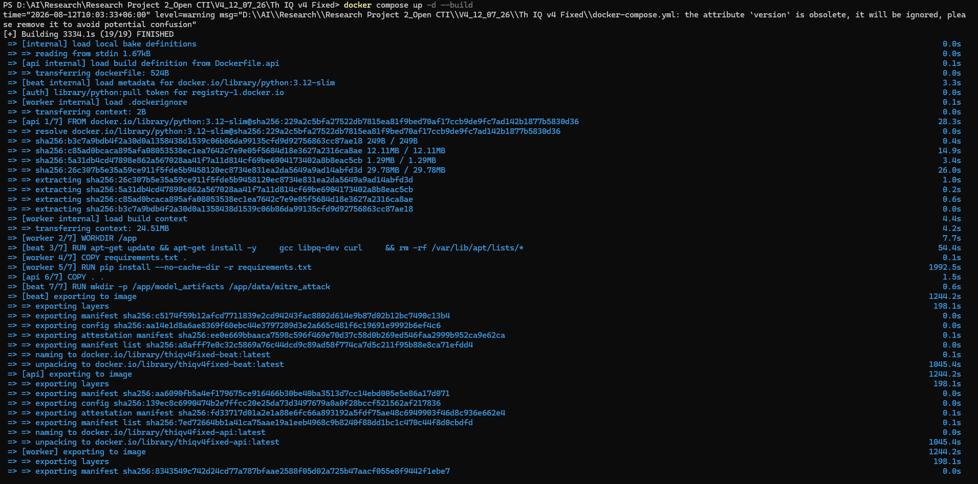
2. Build and start everything
bash
docker compose up -d --build
This builds the api image once and reuses it for worker and beat (they share docker/Dockerfile.api), then starts, in order: postgres → redis → api/worker/beat (gated on the DB/Redis healthchecks).
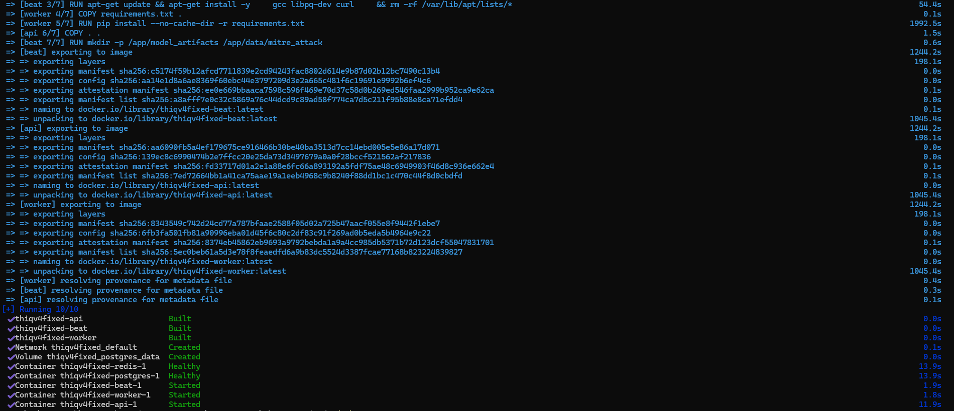
3. Verify it's up
bash
docker compose ps
curl http://localhost:8000/health
Then open http://localhost:8000 for the UI, or http://localhost:8000/docs for the interactive API docs.
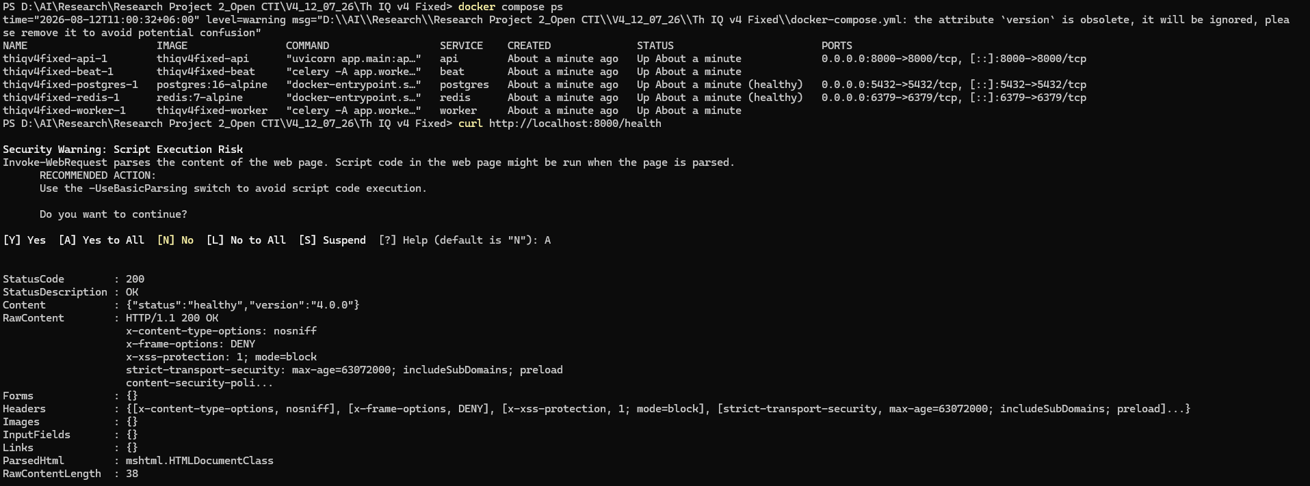
4. Watch logs / debug
bash
docker compose logs -f api # just the API
docker compose logs -f # everything

